Year 6
Curriculum Newsletter
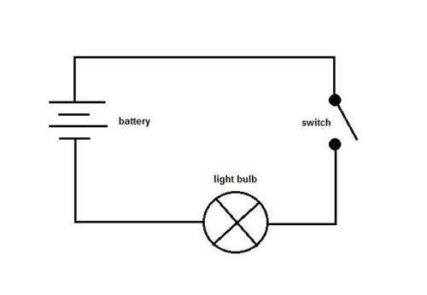
Autumn 1



We hope you have all had a wonderful holiday and that the children are returning to school feeling refreshed and ready for action!
If you have any questions, please make contact with one of the Year 6 team.

Dates for your diary:
- PE – 6C – Tuesday & Thursday. 6LO – Thursday & Friday
- Monday 7th September – Meet the Teacher
- Training Day – Monday 28th September
- School closes for October half term on Friday 23rd October and re-opens on Monday 2nd November.

This half-term, Year 6 will be learning…

English
We will be using a fiction text as a starting point for our learning in English. The book we will be reading is Boy 87 by Ele Fountain.
We will be writing in a range of genres to begin to build a portfolio which will be used to determine attainment in Writing at the end of the year. We will focus on the key features of writing to improve the standard of our writing – including expanded noun phrases, subordination and mature vocabulary.

We encourage children to read as much as possible and children should complete their school reading log. If possible, please listen to your child read and allow them access to a wide range of texts. Any reading your child does will benefit them so from the sports reports in Sunday’s papers to articles online – every bit of reading helps. Please ensure an adult signs the reading record as this will be checked by school staff. Children will be given a raffle ticket when they have read ten times. Every half term, a winner will be drawn to receive a book.

Spellings are also really important as they contribute to their overall SPaG score in the SATs and can influence their attainment in writing. Children should all be bringing home their weekly spellings and can access Spelling Shed at home and at school.

Mathematics
In Mathematics we will be using the Power Maths scheme of work. We will be developing our understanding of numbers up to 10 million, working with fractions and improving our written methods for the four operations.

Science – Electricity
Our new science topic is all about electricity. Children will be making electrical circuits, as well as learning how to draw detailed circuit diagrams. We will also be designing and building games powered by circuits.

Geography
Children will be studying the Alps. Children will explore the similarities and differences between life there and Bradford. They will learn about the population, tourism and develop map reading skills to locate key areas with the Alps.

Design Technology
We will learn about structures. We will learn how to mark out, cut and join materials to make a framework. We will then design, make and evaluate an item to enhance the school playground.

R.E.
Children will develop their knowledge and understanding of Hinduism including worship practices. The unit helps children to understand more about symbols, commitment and service in Hinduism.

Computing
Basic Skills Mini Module 1
Children will develop their typing and presentation skills in an activity linked to their Topic work.
Variables In Games Scratch
This module explores the concept of variables in programming, with games in Scratch. Pupils will find out what variables are and relate them to real-world examples of values that can be set and changed. They will use variables to create a scoreboard simulation. Pupils will experiment with variables in an existing project, then modify them, before they create their own project. Pupils will design, program and improve their games in Scratch.

PSHE – Me and my relationships
Children will develop their skills of being assertive. They will learn how to negotiate and compromise and how this can help us to collaborate effectively. They will look at assertive behaviours and how these can help them to deal with peer pressure.

PE
Ultimate Frisbee
Children will learn the skills necessary to play the invasion game Ultimate Frisbee. They will learn how to pass and catch a frisbee, create space when attacking and work with teammates to limit their opponent’s score.
Hockey
Children will be learning the knowledge and skills necessary to play field hockey. They will learn how to send and receive a hockey ball safely. They will also learn how to travel with a hockey ball and try to outwit opponents in a range of small hockey games.

Music
Children will be learning how songs are created, how to respond to them and play instruments to accompany the songs.

French
We will be starting our new topic ‘Les Sports’ where the children will learn the names of various sports and how to have a conversation about the sports they do and do not enjoy taking part in.

Homework

- New spellings are given out every Monday and are tested the following Monday.
- Maths and English homework is given on a Monday and should be handed in on a Friday.
- Children will be given maths facts to learn at home (Learn By Heart). They will be tested on them each week. LBH objectives will be set and tested on a Friday. The weekly maths homework will reflect this objective. Please make sure children are ready to be tested every Friday.
- Remember - children can log on to TT Rock Stars at home. We will be having regular ‘battles’ between classes this year! https://ttrockstars.com/login.

